**Object Oriented Programming**

**Lab report: 6**



|  |  |
| --- | --- |
| Name | Ali Salman |
| Reg no | FA22-BCE-005 |
| Class | BCE- 4 |
| Instructor’s Name | Prof. Tayyab Rasul |

**Lab 06 – *Static Class Data and Static Member Function***

**Lab Tasks**

Create a SavingsAccount class. Use a static data member annualInterestRate to store the annual interest rate for each of the savers. Each member of the class contains a private data member savingsBalance indicating the amount the saver currently has on deposit. Provide member function calculateMonthlyInterest that calculates the monthly interest by multiplying the balance by annualInterestRate divided by 12; this interest should be added to savingsBalance. Provide a static member function modifyInterestRate that sets the static annualInterestRate to a new value. Write a driver program to test class SavingsAccount. Instantiate two different objects of class SavingsAccount, saver1 and saver2, with balances of $2000.00 and $3000.00, respectively. Set the annualInterestRate to 3 percent. Then calculate the monthly interest and print the new balances for each of the savers. Then set the annualInterestRate to 4 percent, calculate the next month's interest and print the new balances for each of the savers.

**Program:**

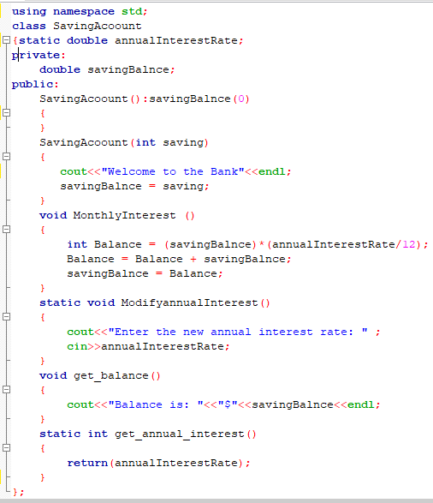

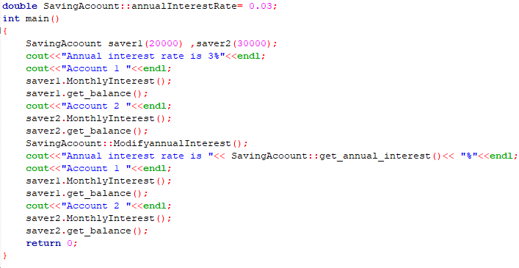

**Output:**

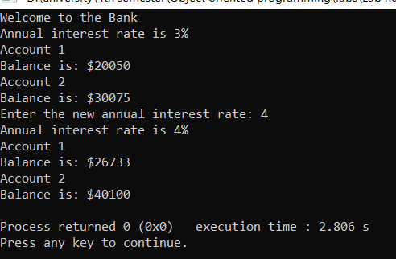

**Home Task:**

Write C++ program to count the number of objects created and destroyed for a class using static data members and static member functions

**Program:**

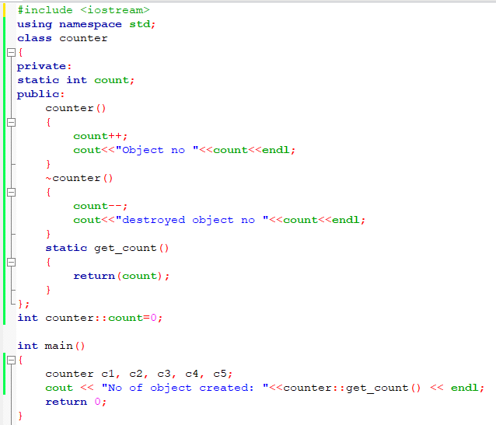

**Output:**

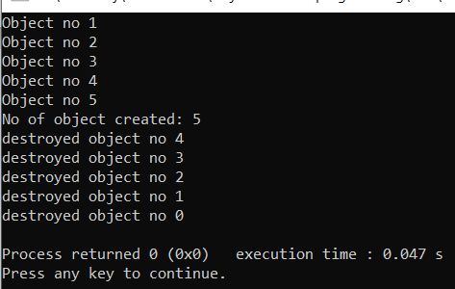

**Critical analysis:**

We learned about static data members and static member functions in this lab. To complete tasks, we have employed members and functions of static data. All objects share the static data member. Only members of static data can be accessed by static functions. The value of the static data member in the main is often obtained using static member functions. Without needing an object, static member functions can be called. Scope resolution is used to initialize static functions. Another thing I've learned is that since we can't access static data members directly in the main, we must utilize static functions instead. Understanding static data members and member functions was made easier by this lab.